Cajun inspired Shrimp and Grits

Serves 4-6 (4 hungry boys, 6 normal folk)

**Ingredients:**

2 cups Heavy whipping cream

2 cups chicken broth or water + chicken bouillon

1 Can of corn (drained)

1 cup polenta

A bunch of green onions, I used 6 sprigs

½ of a medium sized yellow onion

~ 20 medium sized shrimp

Tony’s and/or old bay

**Process:**

1.) Prep:

Clean and cut onions into small pieces, shown below. Thaw and de-tail/shell shrimp.

2.) Bring liquids to simmer in a large pot.

2.5) While liquids are warming up, sauté yellow onion in butter.

3.) Once liquids are at a simmer drop heat to medium-low and add c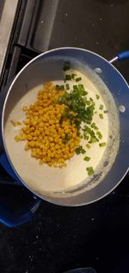orn, polenta and ½ the green onions. Stirring ever 2-3 minutes thoroughly. If you don’t stir, you’ll end up with lumps.

4.) Once Yellow onion begins to brown add shrimp. I coat the shrimp in 30/70 blend of Old Bay/Tony’s. (This is a highly controversial step; do as you see fit.)

5.) Once the shrimp are cooked. Add remaining green onion, spare what you want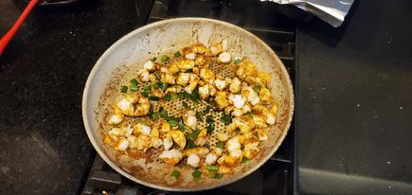 for garnish. Toss to mix. Cook for 2-3 minutes or until green onion becomes crispy.

6.) Pour most of the sautéd onion/shrimp in grits and LIGHTLY mix. You do not want to take the seasoning off the shrimp!

7.) Scoop grits into small serving bowls and garnish with green onions, pepper and remaining shrimp medley. 